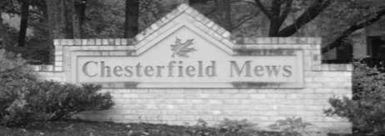

CHESTERFIELD MEWS COMMUNITY ASSOCIATION
ARCHITECTURAL CONTROL APPLICATION FORM

TO: Angela Marshall, Community Association Manager
Sentry Management
7619 Little River Turnpike Suite 210
Annandale, VA, 22003

CC: CMCA ACC Chairs

acc@inthemews.net
amarshall@sentrymgt.com

Applicant Information

Name:______________________________________________________________________________

Mailing Address:______________________________________________________________________

Lots/Residence Address:________________________________________________________________

Email Address:_______________________________________________________________________

Phone Number:_______________________________________________________________________

Proposed Improvements (attach additional page if necessary): For additional information and guidance, please refer to the ACC Guidelines on the inthemews.net website.

APPLICANT MUST SUBMIT THE FOLLOWING WITH THE APPLICATION
- Site plan- showing size, shape, and location of improvement to residence and adjoining properties
- Manufacturer's brochure, if available
- Color samples [provide paint swatches, if applicable
- Architectural plans/drawings [for major additions/improvements]
- Grading Plan, if applicable
- Detailed written description, including expected start and completion dates

APPLICANT HEREBY WARRANTS THAT HE/SHE SHALL ASSUME FULL RESPONSIBILITY FOR:
- All landscaping, grading, and/or drainage issues relating to the improvements
- Obtaining all required city, town or county approvals relating to said improvements
- Complying with all applicable city, town, or county ordinances
- Any damage to adjoining property and common area, or injury to 3rd persons associated with the improvement
- Proper cleanup and restoration

APPLICANT HEREBY STATES THAT HE/SHE HAS READ THE ACC GUIDELINES
AND AGREES THAT ALL WORK WILL BE IN COMPLIANCE WITH THOSE GUIDELINES

Signature of Applicant: ____________________________________ Date: ______________________

ARCHITECTURAL COMMITTEE RESPONSE

Date Application Received:__________________________

_____Request approved as submitted.

____Request approved subject to:

_____Request suspended pending submission of:

_____Request disapproved because:

ACC Member Signature: _______________________________
Printed Name: ______________________
Date: ______________

